December 2023 | PENNYGATE PPG  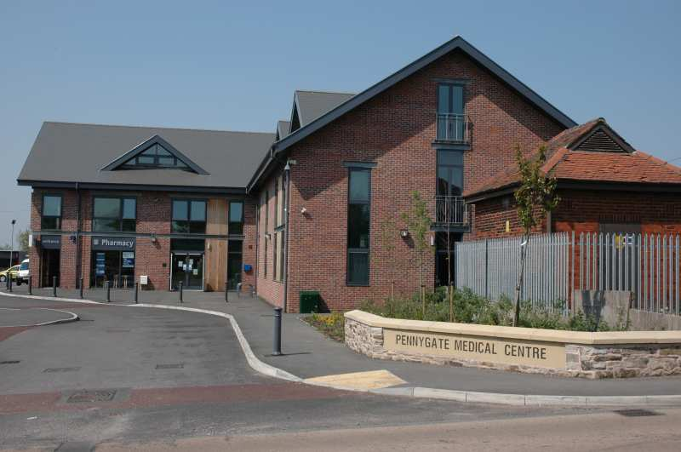  Latest news and bulletin updates

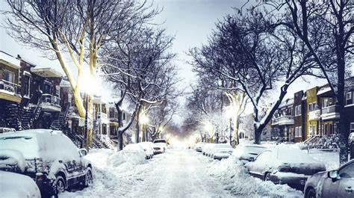
Its wintertime again!!
As we approach winter and the temperatures gets colder and unfortunately, these past couple of years due to covid the energy prices have and are still getting higher. Please find below some helpful information regarding fuel grants, discounts, and handy tips.
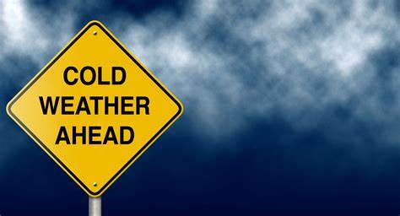
Fuel Grants from the government.
If you were born before 25 September 1957 you could get between £250 and £600 to help you pay your heating bills. This is known as a ‘Winter Fuel Payment’.
The amount you get includes a ‘Pensioner Cost of Living Payment’. This is between £150 and £300. You’ll get this extra amount in winter 2023 to 2024. This is in addition to any other Cost of Living Payments you get with your benefit or tax credits.
Warm home discount scheme.

If you’re on a low income in England and Wales

If you do not get the Guarantee Credit element of Pension Credit, you may still be eligible for the Warm Home Discount. You may be eligible if on 13 August 2023 all the following applied:
your energy supplier is part of the scheme
- you (or your partner) get certain means-tested benefits or tax credits.
- your property has a high energy cost score based on its characteristics.
- your name (or your partner’s) is on the electricity bill.
This is known as being in the ‘core group 2’.
Qualifying benefits and tax credits
The qualifying means-tested benefits are:
- Housing Benefit
- income-related Employment and Support Allowance (ESA)
- income-based Jobseeker’s Allowance (JSA)
- Income Support
- the ‘Savings Credit’ part of Pension Credit
- Universal Credit
You could also qualify if your household income falls below a certain threshold, and you get either:
- Child Tax Credit
- Working Tax Credit
- Your energy cost score
Your property must have a high energy cost score to be eligible for the scheme.
This is not based on the actual energy costs in your energy bill. It’s calculated based on your property’s type, age, and floor area.

How to get the discount

You’ll get a letter between October 2023 and early January 2024 if:
- you’re eligible for the scheme.
- you might be eligible for the scheme, but you need to give more information.
If you’re eligible for the scheme, your letter will confirm you do not need to do anything. You’ll receive the discount automatically.
If you need to give more information, your letter will tell you to call the helpline by 29 February 2024 to confirm your details.
If you’re eligible, your electricity supplier will apply the discount to your bill by 31 March 2024.

If you do not get a letter
Contact the Warm Home Discount Scheme if you do not get the letter by early January 2024 and you think you’re eligible.
You must contact them before 29 February 2024. Warm Home Discount Scheme helpline
Telephone: 0800 030 9322 (Monday to Friday, 8am to 6pm)

Warm, welcoming spaces
This autumn we’ve launched our warm, welcoming spaces in our libraries, galleries, museums and more.
These are safe places you can visit to stay warm and see a friendly face, free of charge and without judgement.
Each of our warm, welcoming spaces are slightly different in what they offer, but we promise that if you do visit, you’ll be met with warmth, kindness, and a friendly Wigan Borough welcome.
You can read the warm, welcoming spaces promise below.

Our promise to you
- Whichever of our spaces you visit, you’ll receive a warm Wigan Borough welcome. Wigan Borough’s people are well known for our strong and kind community spirit, and our warm spaces are no different. We promise that staff and volunteers will treat you with kindness, warmth, and a friendly smile.
- Our warm spaces are a place for everyone, and you’ll be met with no judgement. Whoever you are and whatever your background is - if you’ve been struggling for a long time or this is a new challenge you are facing - you are welcome. We don’t judge anyone, and you will be treated equally and with respect.
- If you need help, just ask - we can point you in the right direction. We know times are hard and it can be tough to ask for help. But if you do choose to start the conversation, our teams can point you in the right direction of the organisations, services and support that might be available to you.
- You can trust us to listen. We are here to lend an ear if you’d like us to listen, but we won’t tell anyone else unless you give us permission to, unless it's a safeguarding issue.
- We’ll play our part, but we’d like kindness to be mutual. We’ve explained how you can expect to be treated, but we would like the feeling to be mutual. Please treat everyone you meet at our warm, welcoming spaces - including visitors, staff, and volunteers - how you would expect to be treated.
You can find warm welcoming spaces – on the wigan, gov.uk website or ask a member of our team and we can print this for you.

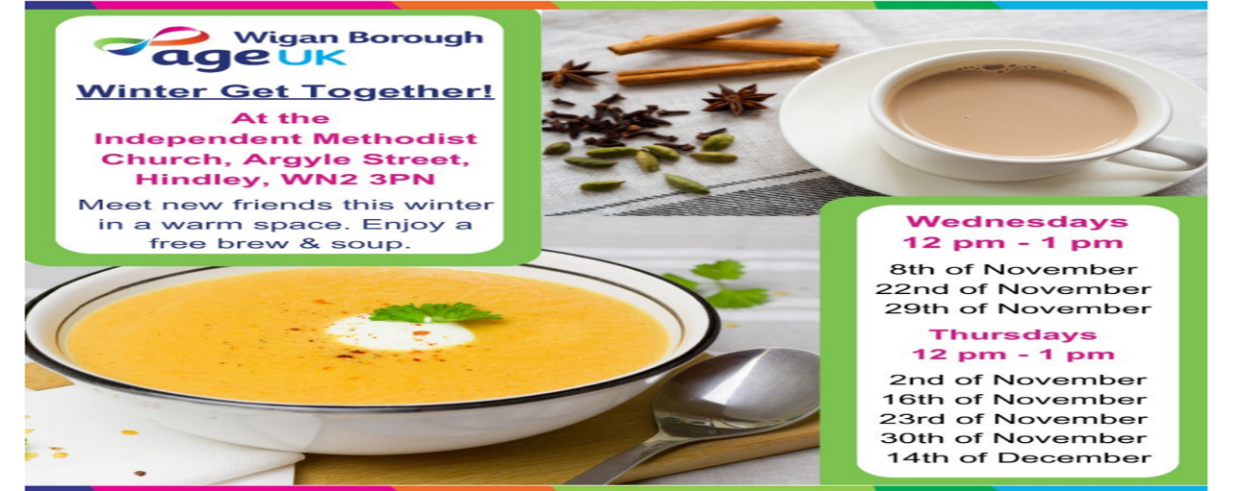

Keeping warm and well in winter

How to keep warm in winter
Extremely cold weather can have a negative impact on our health. People with respiratory problems such as asthma, or heart conditions are at particular risk during the winter months.
Our bodies need to be kept at a core body temperature of 37C to stay healthy, which means rooms should be heated to a minimum of 18C. But with the cost of living still soaring, there are concerns that people will be unable to use heating to keep themselves and their homes warm during the colder months.
Here are some tips on how to keep warm this winter, so you can check in on vulnerable friends, neighbours and family members too.
Keep yourself warm.
There are many things you can do to maintain your core body temperature without turning the central heating on.
1.
Layers: Wearing lots of layers rather than one thick piece of clothing will help to trap your body heat and keep you warmer. Thermal underwear and clothing, and hot water bottles are an inexpensive way to stay warmer for longer. You can also keep your feet warm with thick socks and slippers.
Food and drink: Make sure you eat healthily and drink plenty of hot drinks throughout the day. Avoid alcohol - it prevents your blood vessels from constricting, and you'll begin to lose body heat.
Move around: It's also important to avoid sitting still for long periods of time - move around and keep as active as possible. This will help boost your circulation and keep you warm.

2. Keep your house warm
Heating one room during the day can keep the cost of your energy bill down. There are several ways to warm a room without putting the central heating on.
Curtains: Open your curtains during the day - the sun still provides warmth, even in the winter months. Make sure you close them as soon as the sun sets to keep the warm air in. Investing in thicker curtains, or thermal curtain liners, will help keep the cold air out and prevent heat loss.
Use a draught excluder: We tend to lose a lot of heat through gaps around windows and doors. Exclude draughts by lining your windows with rubber seals and use a homemade draught excluder by doors.
Move furniture away from external walls: Sitting with your back against an internal wall will instantly feel a lot warmer.
Insulate your floor with rugs: If you don't have carpets, put down plenty of rugs. Hardwood or laminate floors are a lot colder than carpeted areas.
Avoid condensation on windows: With the windows closed, condensation can quickly build and can eventually turn to mould. This can be harmful to your lungs. Make sure you turn your extractor fans on in the bathroom and kitchen and wipe down your windows at regular intervals.

3. Staying warm at night
Temperatures really plummet at night, so it's important to keep your bedroom as warm as possible. As with any room, exclude any draughts, close the windows when it's cold and put down rugs to insulate the floor.
Bedding: Use extra blankets or buy flannel or fleece bedding if you can. These materials trap body heat and are better insulators than cotton. Using thicker tog duvets will also provide warmth.
Electric or weighted blankets: An electric blanket is a lot cheaper to run than a heater and provides a constant source of heat throughout the night. Weighted blankets are also very comforting and don't let draughty air into the bed.
Toasty pyjamas: Wearing fleece or flannel pyjamas will go a long way to keeping you warm as they trap the heat. Bed socks will also help you sleep.
Hot water bottle: Cost effective and long lasting, a hot water bottle will provide a safe source of warmth throughout the night.

The flu vaccinations – who should have it and why?
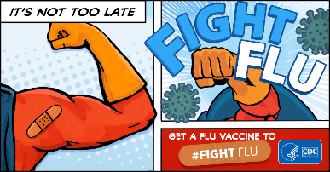
Flu isn’t just a heavy cold. Flu occurs every year, usually in the winter, which is why it’s sometimes called seasonal flu. It’s a highly infectious disease with symptoms that come on very quickly. Colds are much less serious and usually start gradually with a stuffy or runny nose and a sore throat. A bad bout of flu can be much worse than a heavy cold.
The most common symptoms of flu are fever, chills, headache, aches and pains in the joints and muscles, and extreme tiredness. Healthy individuals usually recover within 2 to 7 days, but for some the disease can lead to hospitalisation, permanent disability or even death.
Flu vaccines help protect against the main types of flu virus circulating.
The causes of flu
Flu is caused by influenza viruses that infect the windpipe and lungs. And because it’s caused by viruses and not bacteria, antibiotics won’t treat it. However, if there are complications from getting flu, antibiotics may be needed.
How you catch flu
When an infected person coughs or sneezes, they spread the flu virus in tiny droplets of saliva over a wide area. These droplets can then be breathed in by other people or they can be picked up by touching surfaces where the droplets have landed.
You can prevent the spread of the virus by covering your mouth and nose when you cough or sneeze, and you can wash your hands frequently or use hand gels to reduce the risk of picking up the virus.
But the best way to avoid catching and spreading flu is by having the vaccination before the flu season starts.

How we protect against flu
Flu is unpredictable. Flu vaccination provides the best protection. There are different strains of flu virus. The strains that are most likely to cause illness are identified in advance of the flu season. Vaccines are then made to match them as closely as possible. Even if the vaccine doesn’t perfectly match a strain, it usually provides some protection against it.
The vaccines are given in the autumn ideally before flu starts circulating.
The harm flu can do.
People sometimes think a bad cold is flu, but having flu can often be much worse than a cold and you may need to stay in bed for a few days. In the worst cases, flu can result in a stay in hospital, or even death.
Some people are more susceptible to the effects of flu. For them, it can increase the risk of developing more serious illnesses such as bronchitis and pneumonia or can make existing conditions worse.
Wishing all our patients a merry Christmas and happy new year!! From all the PENNYGATE team and the PENNYGATE PPG Members.

